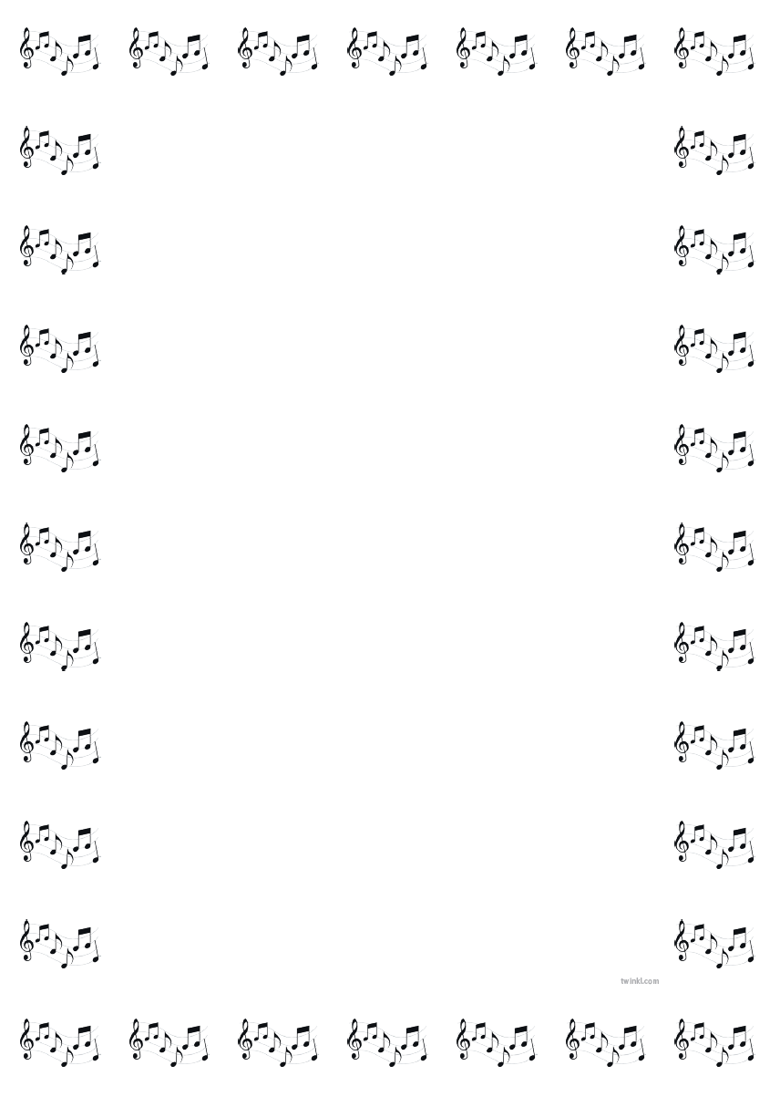
SPECIAL AWARDS 2022

D’Arcy Cup + £250, £100 and £50 for the three most promising instrumentalists in the Festival.

1. Jack Myles. 2. Caleb Lawrence. 3. Cab Han Keag

Cattogs Cup + £50 for the highest mark in Music Theatre classes F13-F21

Erin Tumlison

Sharon Yarr Award of 350 to the performer with the highest mark in Piano classes A6-A8
Saoirse Rippon

McWhirk Cup + £50 for the performer with the highest mark in Vocal classes B1-B15
Thomas Laughrey

Laiseran Junior Trophy + £30 for the performer with the highest mark in Traditional classes D1-D4

Cara Keag

Laiseran Senior Trophy + £40 for the performer with the highest mark in Traditional classs D11-D3

Jamie Rice

Fox-Roberts Cup + £40 music vouchers for the highest mark in Traditional classes D8-D10

St Comgall’s Primary School

Barry Douglas Cup for the performer with the highest mark in Piano classes A2-A5

Catherine McLaughlin

Rowel B Friers Memorial Trophy for the performer with the highest mark in Piano classes A9-A13

Senan Sheridan

Burnside Shield for the Best Secondary School Choir

St Malachy’s College Chamber Choir

Foster Shield for the singer with the highest mark in Music Theatre classes F1-F7

Martha Greer

